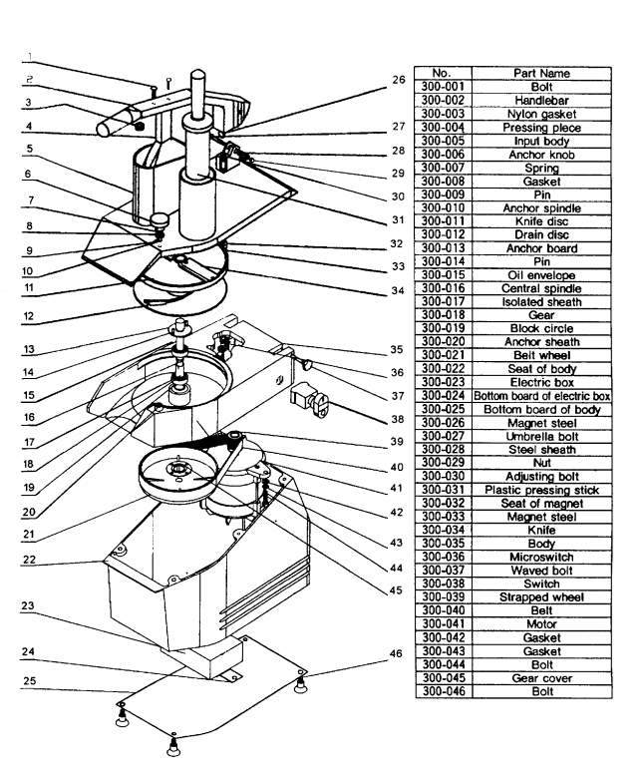

list for spare parts
No. | Part Name
300-001 | Bolt
300-002 | Handlebar
300-003 | Nylon gasket
300-004 | Pressing piece
300-005 | Input body
300-006 | Anchor knob
300-007 | Spring
300-008 | Gasket
300-009 | Pin
300-010 | Anchor spindle
300-011 | Knife disc
300-012 | Drain disc
300-013 | Anchor board
300-014 | Pin
300-015 | Oil envelope
300-016 | Central spindle
300-017 | Isolated sheath
300-018 | Gear
300-019 | Block circle
300-020 | Anchor sheath
300-021 | Belt wheel
300-022 | Seat of body
300-023 | Electric box
300-024 | Bottom board of electric box
300-025 | Bottom board of body
300-026 | Magnet steel
300-027 | Umbrella bolt
300-028 | Steel sheath
300-029 | Nut
300-030 | Adjusting bolt
300-031 | Plastic pressing stick
300-032 | Seat of magnet
300-033 | Magnet steel
300-034 | Knife
300-035 | Body
300-036 | Microswitch
300-037 | Waved bolt
300-038 | Switch
300-039 | Strapped wheel
300-040 | Belt
300-041 | Motor
300-042 | Gasket
300-043 | Gasket
300-044 | Bolt
300-045 | Gear cover
300-046 | Bolt
 | Disc Holder

